Create a S3 bucket, with no public access and upload files to the bucket & view the logs for the uploaded files.

Create a S3 bucket, with no public access:

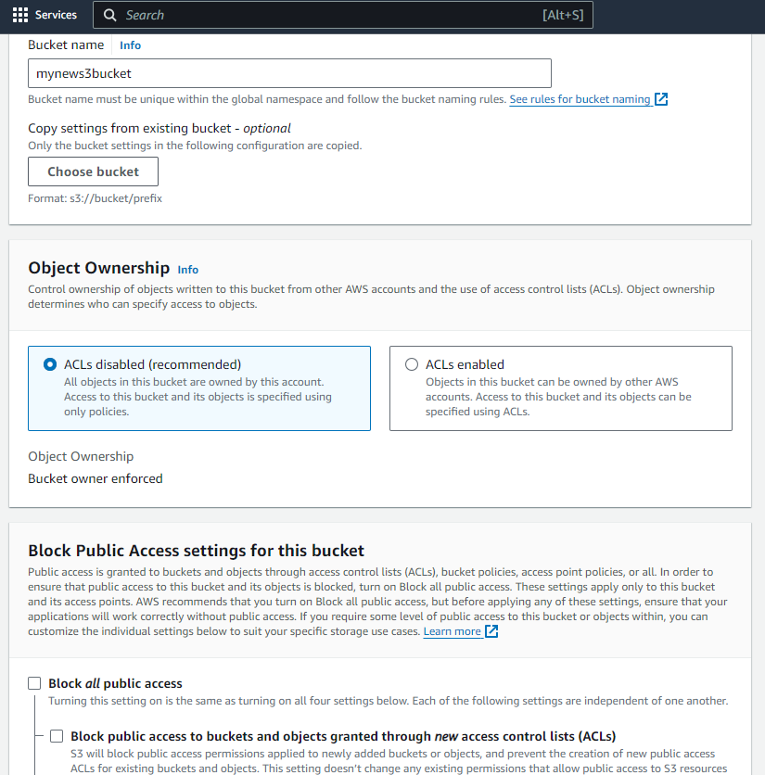 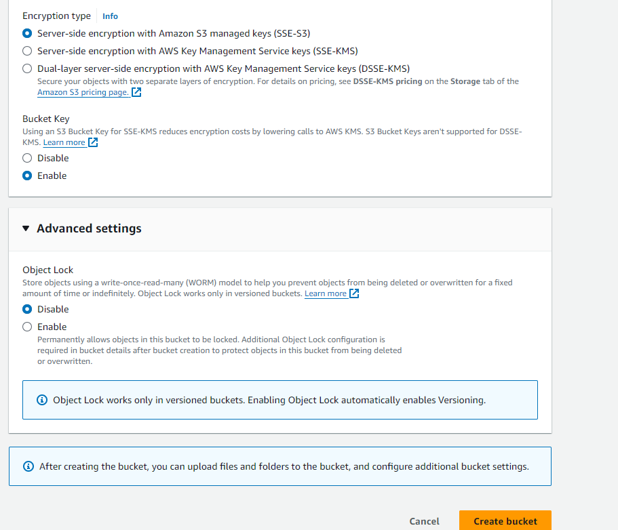

Uploading files to the bucket:

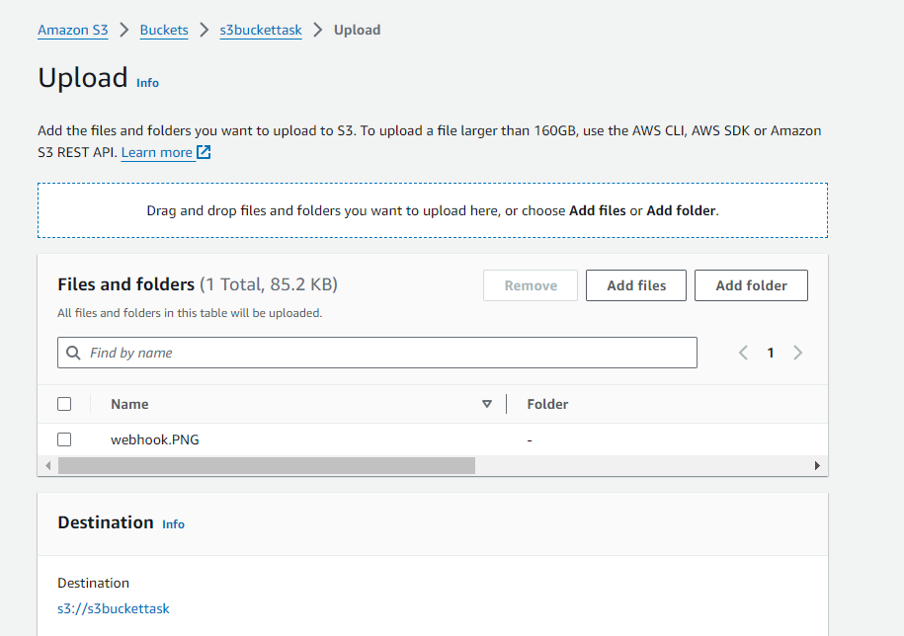

View the logs for the uploaded files:

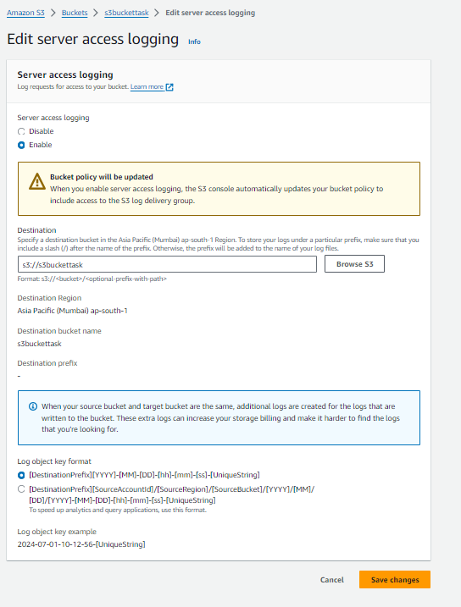

Adding code to the two EC2 instances:

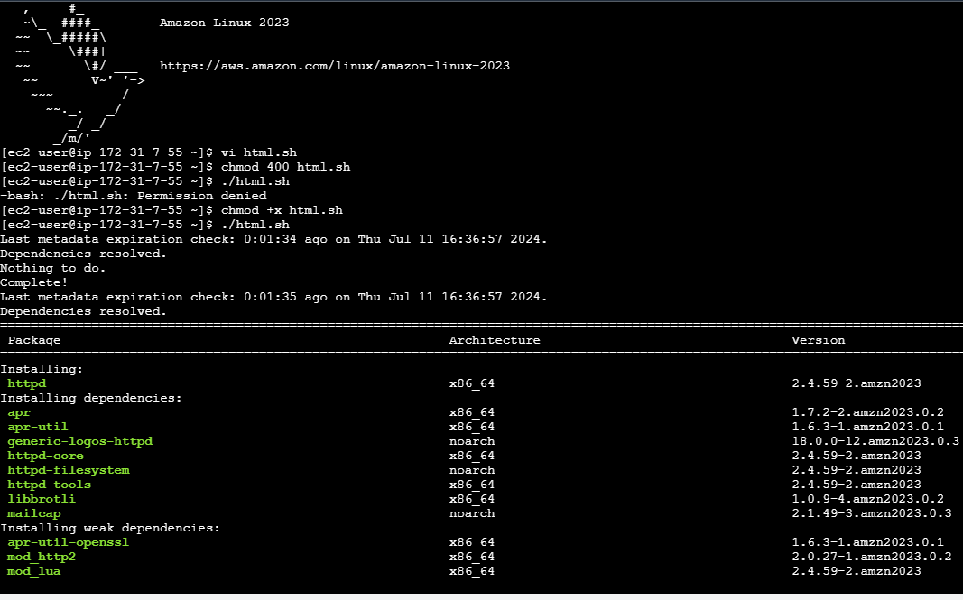

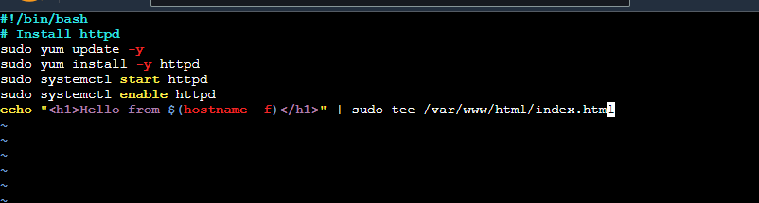

OUTPUT:

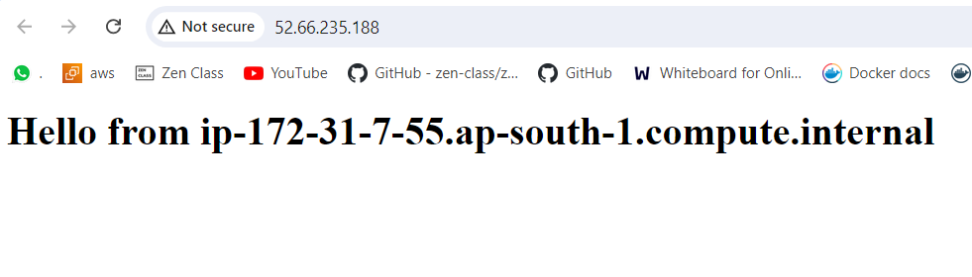

LOGS:

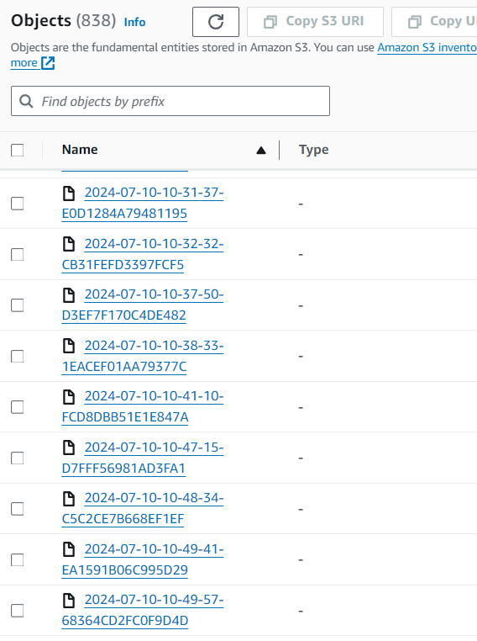

Launch two ec2-instances and connect it to a application load balancer, where the output traffic from the server must be an load balancer IP address

Creating application load balancer:

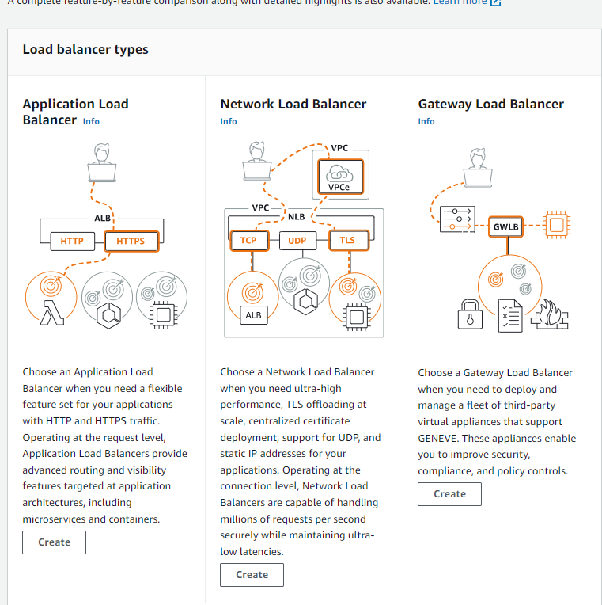

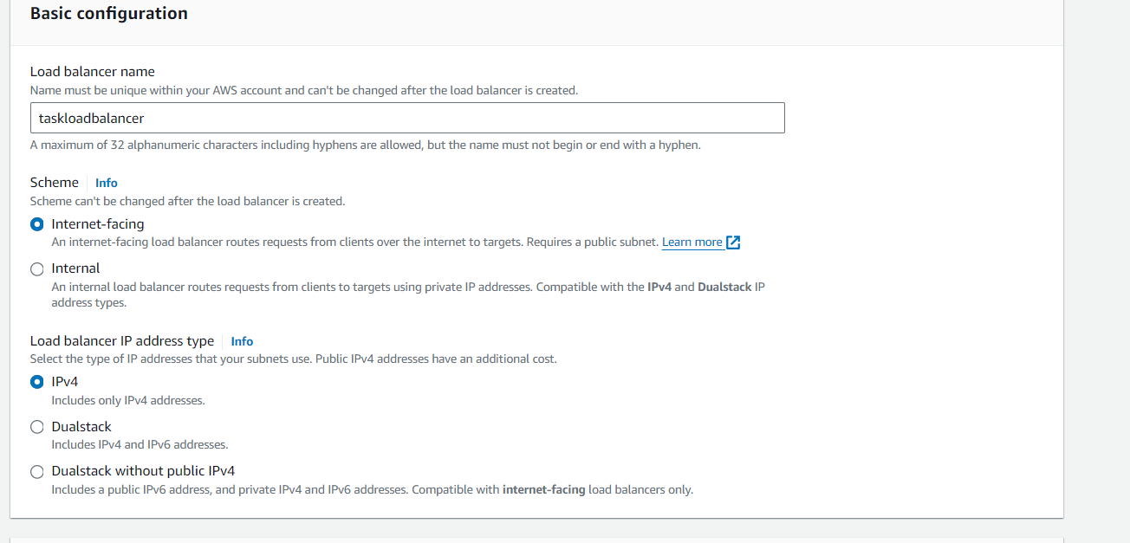

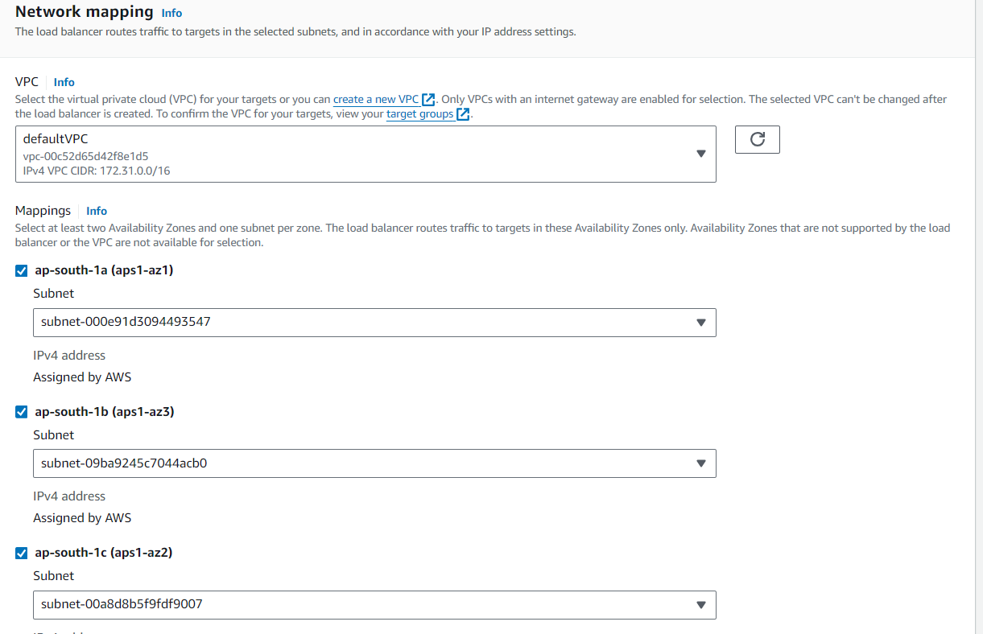

Create target:

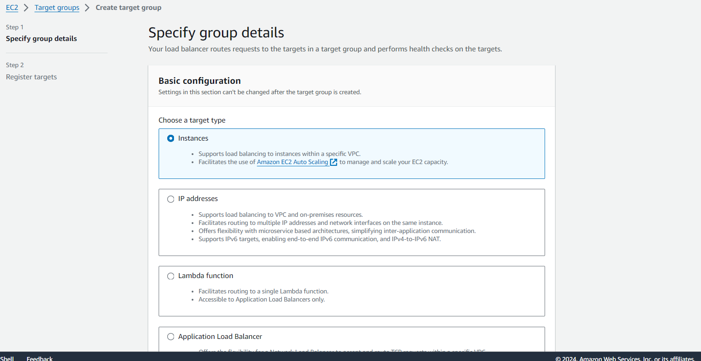

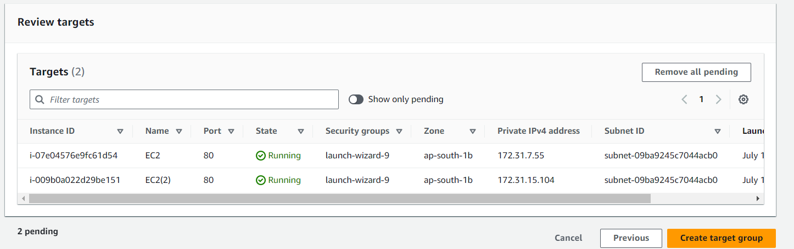

Add target group for creating application load balancer:

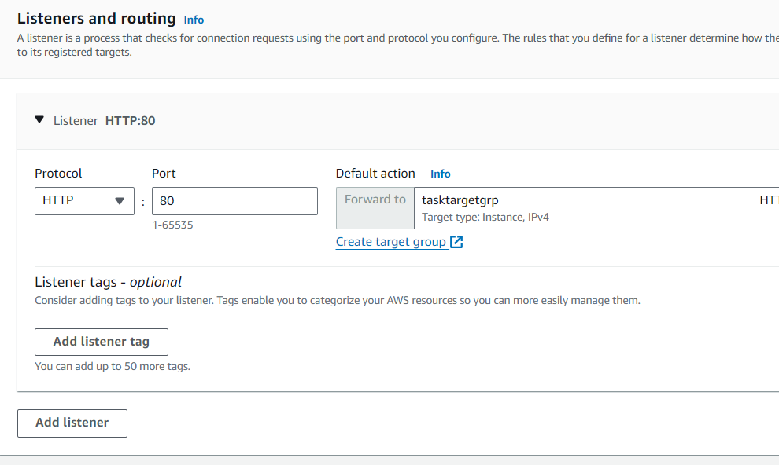

Once initial changes to healthy in target group, DNS name can be used,

